**Heart Attack Possibility Prediction**

**Milestone: Performance evaluation and interpretation**

Group 18

Student 1 Karan Paresh

Student 2 Tianyu Yang

857-294-7660 (Tel of Karan Paresh)

617-368-0332 (Tel of Tianyu Yang)

[samani.k@northeastern.edu](mailto:samani.k@northeastern.edu)

[yang.tianyu@northeastern.edu](mailto:yang.tianyu@northeastern.edu)

**Percentage of Effort Contributed by Student 1: 50%**

**Percentage of Effort Contributed by Student2: 50%**

**Signature of Student 1: Karan Paresh**

**Signature of Student 2: Tianyu Yang**

**Submission Date: 11/15/2021**

**Performance Evaluation and Interpretation**

**Modeling: -**

1. Logistic Regression: -

The first model which we are using is the logistic regression model.Using the metrics we get the

accuracy, precision, Recall and F1-score .

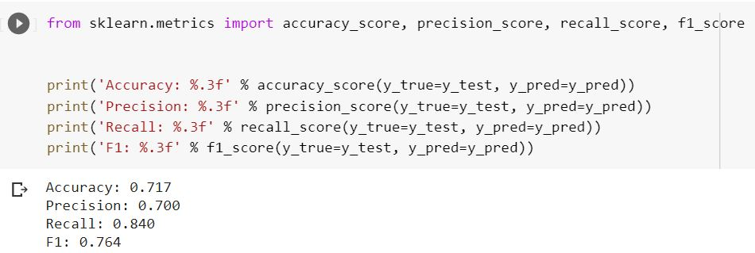

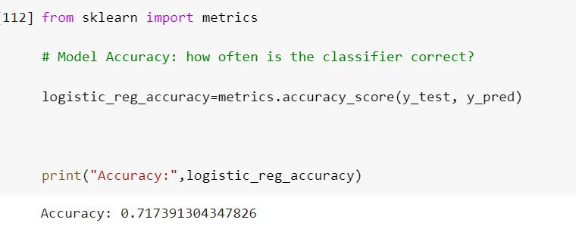The accuracy score for the model is 71.7%.

The Roc_auc score for the model is 78%.

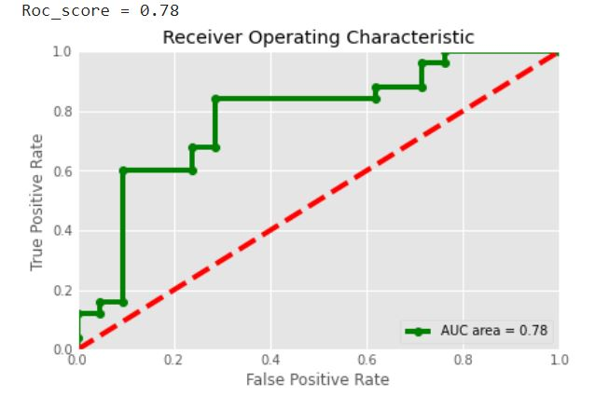

2. Support Vector Machine: -

The second classification model which we are using is Support Vector Machine. Using the metrics we

get the accuracy, precision, Recall and F1-score .

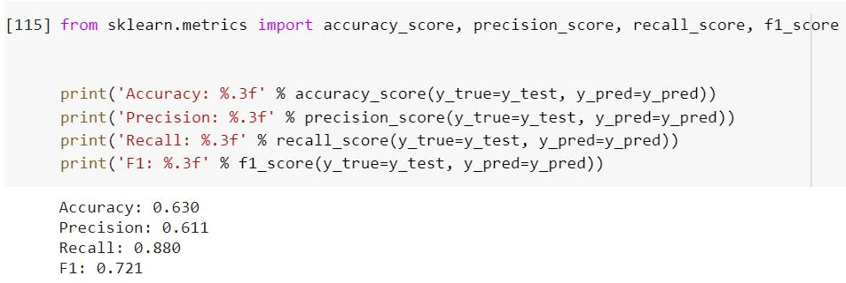

The accuracy score for the model is 63%.

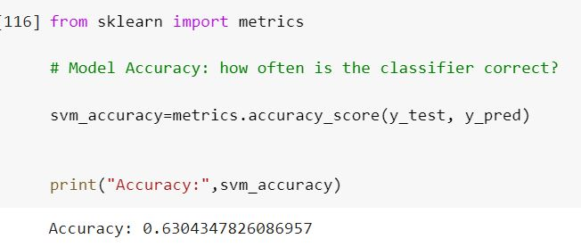

The Roc_auc score for the model is 77%.

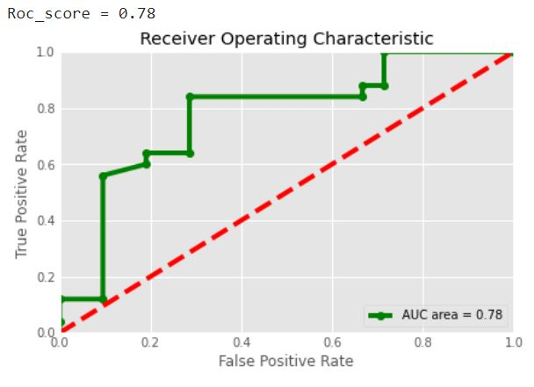

3. Gaussian Naïve Bayes: - (Best Model)

The third model which we are using is Gaussian Naive Bayes. Using the metrics we

get the accuracy, precision, Recall and F1-score .

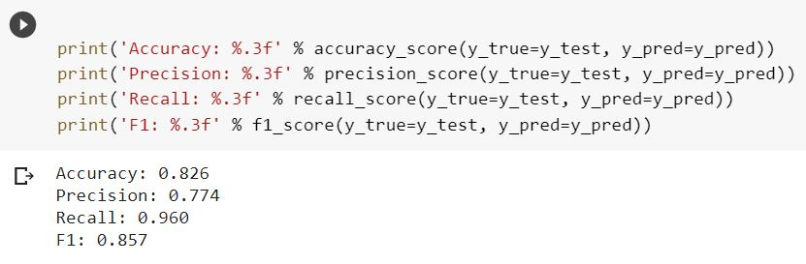We use the gaussian naive bayes model to classify the class whether the patient will suffer from "Heart attack" or not. We use this model because every feature in this data is independent of each other and its relation to the target variable is also independent. The model is able to predict the results with 82.6% accuracy which is relatively decent.

The accuracy score for the model is 82.6%.

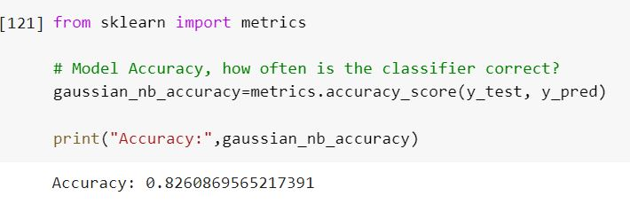

The Roc_auc score for the model is 89%.



4. K-Nearest Neighbours: -

The fourth classification model we use is KNN. Using the metrics we get the accuracy, precision, Recall and F1-score .

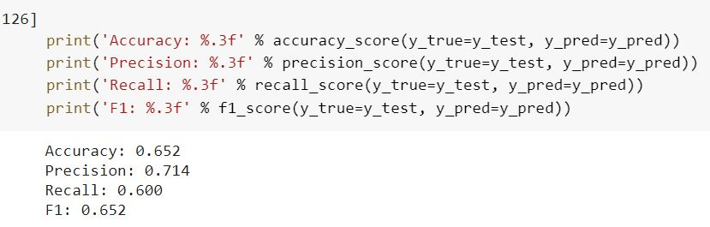

The accuracy score for the model is 65.2%.

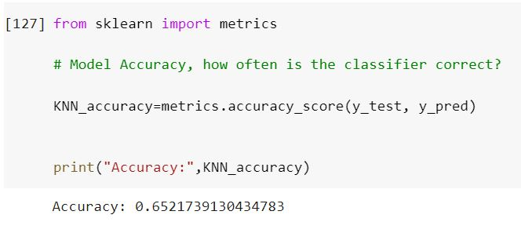

The Roc_auc score for the model is 65%.

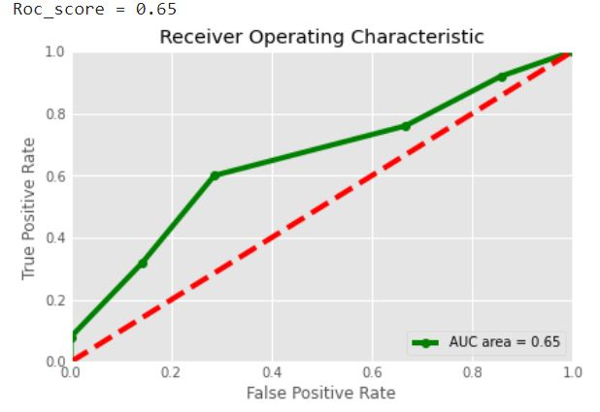

5. DecisionTree Classifier: -

The fifth classification model we are using is DecisionTree classifier. Using the metrics we get the accuracy, precision, Recall and F1-score .

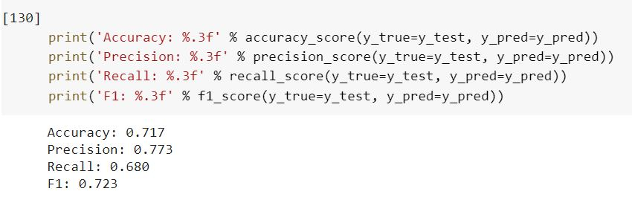

The accuracy score for the model is 71.7%.

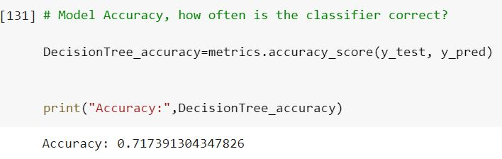

The Roc_auc score for the model is 76%.

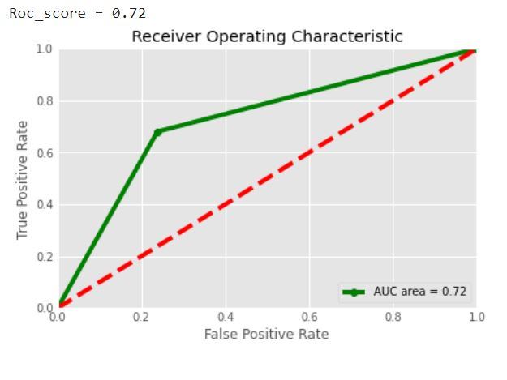

Comparing the models using accuracy score: -

Results: -

The barplot shows the Gaussian Naive bayes model performs the best amongst all the classification models that we used.

The accuracy of the models follows the order as listed: -

1.Gaussian naive bayes (Best model)

2.Decission Tree

3.Logistic Regression

4.K-Nearest-Neighbors

5.Support vector Machine

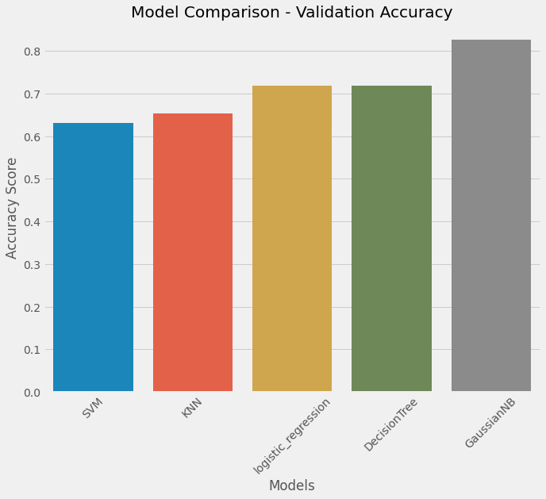

Comparing the models using Roc_auc score: -

Results: -

The barplot shows the Gaussian Naive bayes model performs the best amongst all the classification models that we used.

The Roc_auc of the models follows the order as listed: -

1.Gaussian naive bayes (Best model)

2.Decission Tree

3.Logistic Regression

4.K-Nearest-Neighbors

5.Support vector Machine

